
Stottesdon and Sidbury Parish Council
Clerk: Mrs Freda Morris
18 Glebe Drive
Stottesdon
Kidderminster
Worcs
DY14 8UF

Telephone: 01746 718453
E-mail: stottesdonpc@btinternet.com

Date: 8th December 2013
To: All Parish Council members
The Public and Press

A Parish Council meeting will be held on MONDAY 16th DECEMBER 2013 at 7.30pm in CHORLEY VILLAGE HALL for the transaction of business as set out in the agenda below which you are summoned to attend.

Yours sincerely

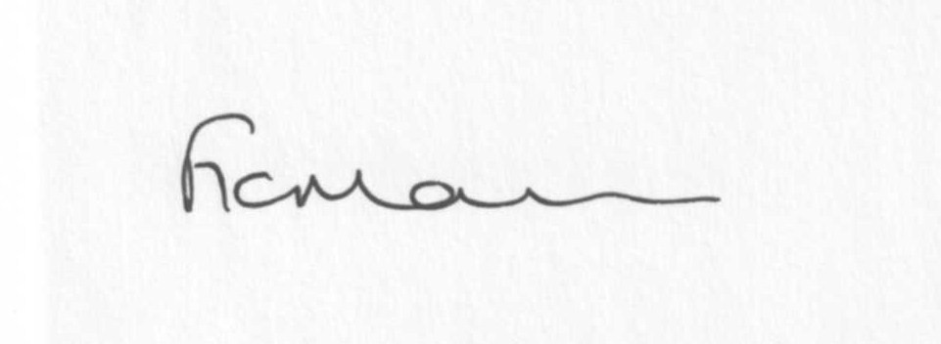
Mrs F Morris
Clerk to the Parish Council

AGENDA

0) Public participation (maximum 15 minutes)
1) Apologies for absence
2) Declaration of Interests
The Localism Act 2011, Relevant Authorities (Disclosable Pecuniary Interests) Regulations 2012.
Members are reminded that they are required to leave the room during the discussion and voting on matters in which they have a disclosable pecuniary interest, whether or not the interest is entered in the register of member’s interests maintained by the Monitoring Officer.
3) To confirm minutes of the meeting held on 28th November 2013 (copy attached)
4) Matters Arising from the minutes
(a) Progress report (distributed at meeting)
(b) Reply from SC re: parish problems
(c) Any other matters arising
5) School Bus – reply from Oldbury Wells School re: mini bus pick up/drop off
6) Planning applications:
a) Reference: 13/04879/FUL (validated: 04/12/2013)
Address: Coppice Barn, Chorley, Bridgnorth, Shropshire, WV16 6PP
Proposal: Erection of Oak Framed Garage including driveway and access.
Applicant: DKM Homes Ltd (Harpsford Mill Barn, Ludlow Road, Harpsford Mill Barn, Bridgnorth, Shropshire, WV16 5NN)

b) Any other plans received after issue of the agenda

c) Planning permissions/refusals:
Reference: 13/04106/FUL (validated: 10/10/2013)
Address: Cherry Orchard Cottage, Chorley, Bridgnorth, WV16 6PP
Proposal: Erection of single storey rear extension
Decision: Grant Permission

Any others received after issue of the agenda

7) SALC report
8) Unitary Councillor’s report
9) Financial matters:
a) Outstanding payments: Clerks fees/HMRC PAYE, SLCC subs.
Any others received after issue of the agenda
b) Income since last meeting - confirmed at meeting
c) Bank statement
d) Precept
e) Ipad information
10) Parish matters/problems
a) Parish problems
b) Parish Watch
c) Dog Control Order signs
d) Community Right to Bid
11) Annual Place Plan review 2013-14
12) Correspondence:
Emails forwarded:
SALC Bulletins
Rural Services Network newsletters
SALC Update on Planning
SC – Road closure:
Road to be closed: Lower Woodend to Six Ashes xrds
Date of closure: 13th January 2014
Time and duration: 5 days; 07:30hrs – 16:00hrs
Purpose: Drainage works
Applicant: Shropshire Council
SALC – Mobile Infrastructure Project
SALC – Death of Localism and NNPF over SamDev
Reply from SC – re: parish signs
Any others received after issue of the agenda
13) Date of next meeting – 27th January 2014
14) Update: Car parking/playing field **
**Due to the confidential nature of the business to be discussed under item 14 the public and press shall be excluded under s1 (2) Public Bodies (Admission to Meetings) Act 1960 as amended

Please note:
Deadline for newsletter articles is 12 noon on 5th January 2014.
Any articles received after this date will not be included.

