
Stottesdon and Sidbury Parish Council
Clerk: Mrs Freda Morris
18 Glebe Drive
Stottesdon
Kidderminster
Worcs
DY14 8UF

Telephone: 01746 718453
E-mail: stottesdonpc@btinternet.com

Date: 8th September 2013
To: All Parish Council members
The Public and Press

A Parish Council meeting will be held on MONDAY 16th SEPTEMBER 2013 at 7.30pm in CHORLEY VILLAGE HALL for the transaction of business as set out in the agenda below which you are summoned to attend.

Yours sincerely

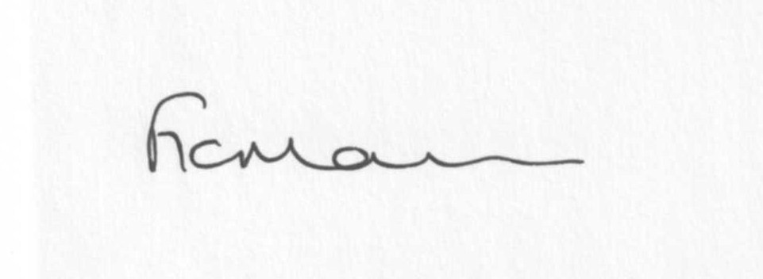

Mrs F Morris
Clerk to the Parish Council

AGENDA

0) Public participation
1) Election of Chairman following resignation of current Chairman
2) Signing of Declaration of acceptance of office of new Chairman
3) Apologies for absence
4) Declaration of Interests
The Localism Act 2011, Relevant Authorities (Disclosable Pecuniary Interests) Regulations 2012.
Members are reminded that they are required to leave the room during the discussion and voting on matters in which they have a disclosable pecuniary interest, whether or not the interest is entered in the register of member’s interests maintained by the Monitoring Officer.
5) To confirm minutes of the meeting held on 19th August 2013 (copy attached)
6) Matters Arising from the minutes
(a) Progress report (distributed at meeting)
(b) Responses received re: School field/community use/ Open meeting
(c) Hedge near Rays Farm
(d) SC – confirmation that potholes will be filled before white lining commences
(e)Any other matters arising
7) Planning applications:
a) Reference: 13/03265/FUL (validated: 20/08/2013)
Address: The Crest, Chorley, Bridgnorth, Shropshire, WV16 6PP
Proposal: Erection of part two storey and part single storey extension to rear elevation
Applicant: Mr Tom Casswell

b) Reference: 13/03269/FUL (validated: 22/08/2013)
Address: Lower Chorley Farm, Chorley, Bridgnorth, Shropshire, WV16 6PP
Proposal: Erection of a building for use as workshop and oak frame assembly area
Applicant: Mr Norman Jones

c) Any others received after issue of the agenda

d) Planning permissions/refusals:
Reference: 13/02664/FUL (validated: 17/07/2013)
Address: Cox’s Barn, Stottesdon, Kidderminster, DY14 8LS
Proposal: Erection of two storey extension to garage; raise the roof level of the garage by 900mm, and extend the garage back by 3600mm, in order to create a larger bathroom with more head room and to allow for an internal staircase
Decision: Grant Permission
8) SALC report
9) Unitary Councillor’s report
10) Financial matters
a) Outstanding payments: Clerks fees/expenses; SALC training account; Any others received after issue of the agenda
b) Income since last meeting - confirmed at meeting
c) Bank statement
d) To consider purchasing the New Cllrs Guide @ £2 each
11) Parish matters/problems
a) Parish problems
b) Parish Watch
12) Correspondence:
Emails forwarded:
ROAD CLOSURES
a) Brookland to Well Farm junction, Farlow (Section 50m either side of Farlow Bridge) 14 October 2013 – 2 Weeks – Bridge Repairs
b) Road to be closed: Lower Woodend jct to Six Ashes jct with B4363
Date and duration: 28th October 2013 for 1 day (08:00hrs to 16:00hrs)
Purpose: To allow BT customer fault repair
Applicant: A Plant Lux
SC – Speeding restrictions, Chorley
RSN – Rural Vulnerability Service Broadband
RSN – Evidence about your local area
SC – Complaint received re: parking in recycling lay by at Stottesdon
SALC - Training events
SALC – Draft Community Engagement Strategy Consultation from West Mercia Police
Electoral Roll amendments
Any others received after the issue of the agenda
13) Items for next agenda
14) Date of next meeting – 21st October 2013 - Please note change of date!
15) Update: Car parking/playing field
Due to the confidential nature of the business to be discussed under item 15 the public and press shall be excluded under s1 (2) Public Bodies (Admission to Meetings) Act 1960 as amended

