
Stottesdon and Sidbury Parish Council
Clerk: Mrs Freda Morris
18 Glebe Drive
Stottesdon
Kidderminster
Worcs
DY14 8UF

Telephone: 01746 718453
E-mail: stottesdonpc@btinternet.com

Date: 11th August 2013
To: All Parish Council members
The Public and Press

A Parish Council meeting will be held on MONDAY 19th AUGUST 2013 at 7.30pm in CHORLEY VILLAGE HALL for the transaction of business as set out in the agenda below to which you are summoned to attend.

Yours sincerely

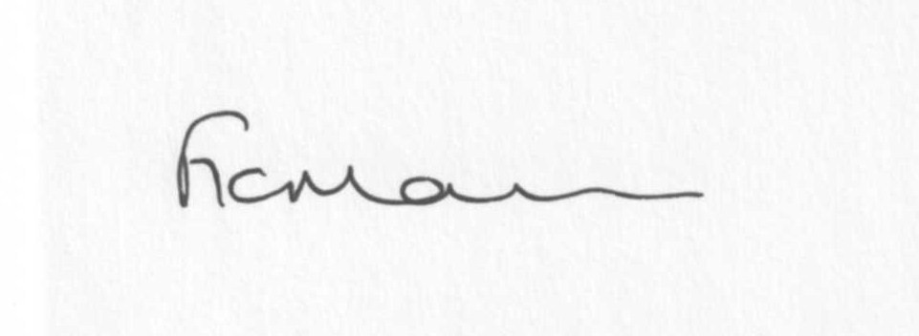

Mrs F Morris
Clerk to the Parish Council

AGENDA:

0) Public participation
1) Apologies for absence
2) Declaration of Interests:
The Localism Act 2011, Relevant Authorities (Disclosable Pecuniary Interests) Regulations 2012.
Members are reminded that they are required to leave the room during the discussion and voting on matters in which they have a disclosable pecuniary interest, whether or not the interest is entered in the register of member’s interests maintained by the Monitoring Officer.
3) To confirm minutes of the meeting held on 22ND July 2013 (copy attached)
4) Matters Arising from the minutes
(a) Progress report (distributed at meeting)
(b) Reply from Cllr Butler re: community use of school field
(c) Reply from SC re: parish problems
(d) Any other matters arising
5) Dispensations:
Requests for dispensations should be sent in writing to the Clerk prior to the meeting.
6) Co-options
7) Signing of Declarations
8) Planning applications:
a) Any received after issue of the agenda
b) Permissions/refusals
9) SALC report
10) Unitary Councillor’s report
11) Financial matters:
a) Outstanding payments:
SALC account – training
Clerk’s fees
HMRC PAYE
Any others received after issue of the agenda.
b) Income since last meeting (confirmed at meeting)
c) Budget reconciliation (distributed at meeting)
d) Bank statements
12) Parish matters/problems
a) Parish problems
b) Parish Watch
13) Correspondence:
Including emails forwarded to Cllrs:
SC - ROAD CLOSURE – B4555 The Cankhorn, Eardington (Section from The Cankhorn to 22 Knowle Sands Caravan Park) 7 October 2013 – 15 Weeks – New Gravity Sewer Installation
SC – road markings in Stottesdon
Rural Services Network newsletters
SALC Bulletins
Complaint re: horses and tractors
SALC - Re-design of Shropshire Councils' Highways & Transport Team
SC - Alterations to the electoral register
SALC - Training Events Update
Shaping your outdoors - the newsletter of Shropshire Council's Outdoor Recreation Service – link: http://www.shropshire.gov.uk/media/501956/OutdoorRecreationNewsletterSummer2013.pdf
An update from your MP
Letter from MP re: wind turbines
Any others received after issue of the agenda
14) Newsletter distribution
15) Date of next meeting – 23rd September 2013
16) Update on parking/playing field**
**Due to the confidential nature of the business to be discussed under item 16 the public and press shall be excluded under s1 (2) Public Bodies (Admission to Meetings) Act 1960 as amended

