
Stottesdon and Sidbury Parish Council
Clerk: Mrs Freda Morris
18 Glebe Drive
Stottesdon
Kidderminster
Worcs
DY14 8UF

Telephone: 01746 718453
E-mail: stottesdonpc@btinternet.com

Date: 13th March 2012
To: All Parish Council members
The Public and Press

A Parish Council meeting will be held on MONDAY 19th MARCH 2012 at 7.30pm in CHORLEY VILLAGE HALL for the transaction of business as set out in the agenda below which you are summoned to attend.

Yours sincerely
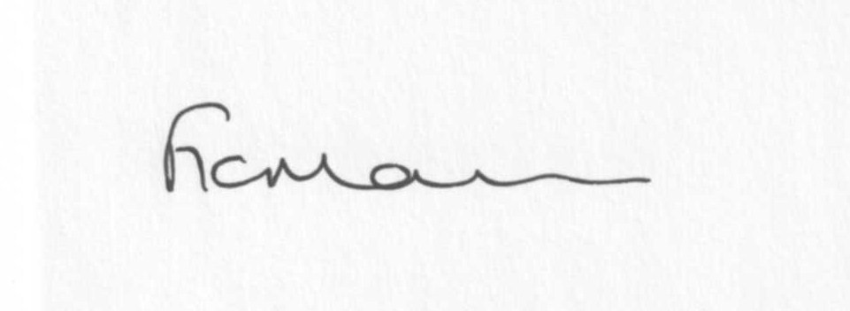
Mrs F Morris
Clerk to the Parish Council

AGENDA

0) Public participation – 15 minutes
1) Apologies for absence
2) Declaration of Interests
“To receive declarations of Interest of personal and prejudicial interest on any item on the agenda in accordance with Section 50-52 of the Local Government Act & The Local Authorities (Model Code of Conduct) England Order 2001”.
3) To confirm minutes of the meeting held on February 27th 2011(copy attached)
4) Matters Arising from the minutes
(a) Progress report (distributed at meeting)
(b) Any other matters arising
5) Planning applications:
a) Works to include insertion of windows, doors and rooflights; with internal alterations to South Barn and Gate House all to facilitate conversion to residential accommodation (modification to previously approved 10/02998/LBC) - Chorley Manor, Chorley – application number: 12/00983/LBC
b) Any others received after issue of agenda
c) Planning permissions granted – Bardley Cottage, Bagginswood.
d) Plans withdrawn – Firien Barn, Bagginswood
6) Shropshire Councillor’s report
7) ALC report
8) Financial matters:
a) Clerk’s fees/expenses
b) PAYE
c) Accounts to be paid – Willowdene. Any others received after issue of the agenda.
d) Donation requests from Nightingale Nursing Fund, Marie Curie, Samaritans, Pat Straughan RDA
e)Bank statement
9) Jubilee celebrations update
10) Correspondence – including emails:
Receipt re: Stotty Shop
Weekly Planning lists
SC – Mobile library changes
SC – Fire Safety Awareness Briefing by Shropshire Fire and Rescue Service
ALC – Information Bulletins (weekly)
SC Enforcement – Old Fox and Hounds car park
SC – Emergency Plan template
www.localcouncilinfo.com
ALC – Broadband
‘HereSay’ email
Council Tax increase email
Any others received after the issue of the agenda
11) Parish matters/problems
a) Parish problems
b) Parish Watch
12) Format for future agendas
13) Date of next meeting – 16th April (Annual Parish Meeting)
23rd April (Parish Council)

Deadline for newsletter articles is 12 noon on 1st April 2012.

