
Stottesdon and Sidbury Parish Council
Clerk: Mrs Freda Morris
18 Glebe Drive
Stottesdon
Kidderminster
Worcs
DY14 8UF

Telephone: 01746 718453
E-mail: stottesdonpc@btinternet.com

Date: 14th August 2012
To: All Parish Council members
The Public and Press

A Parish Council meeting will be held on MONDAY 20th AUGUST 2012 at 7.30pm in CHORLEY VILLAGE HALL for the transaction of business as set out in the agenda below which you are summoned to attend.

Yours sincerely

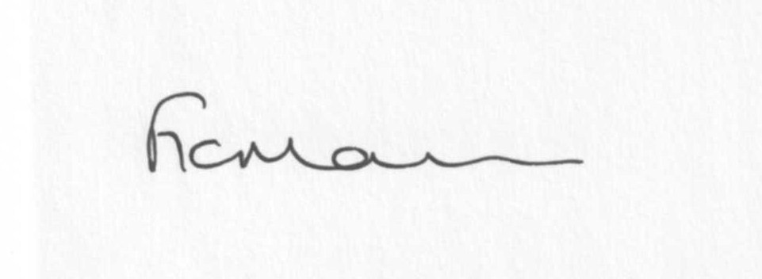

Mrs F Morris
Clerk to the Parish Council

AGENDA

0) Public participation
1) Apologies for absence
2) Declaration of Interests:
The Localism Act 2011, Relevant Authorities (Disclosable Pecuniary Interests) Regulations 2012.
Members are reminded that they are required to leave the room during the discussion and voting on matters in which they have a disclosable pecuniary interest, whether or not the interest is entered in the register of members interests maintained by the Monitoring Officer.
3) To confirm minutes of the meeting held on 23rd July 2012 (copy attached)
4) Matters Arising from the minutes:
(a) Clerk’s report (distributed at meeting)
(b) Any other matters arising
5) Planning applications:
a) Erection of a portal framed livestock building – Pickthorn Farm, Chorley (no: 12/02965/FUL)
b) Permissions/refusals
c) Any others received after issue of agenda
6) SALC report
7) Shropshire Councillor’s report
8) Financial matters:
a) Outstanding payments: Clerk’s fees/expenses. Any others received after issue of agenda.
b) Income since last meeting (confirmed at meeting)
c) Bank statement
9) Bus shelter update
10) Parish matters/problems
a) Parish problems
b) Parish Watch
c) Parish Plan update
11) Correspondence including emails forwarded to Councillors:
Weekly Planning lists
Rural Service Network newsletters
24/7 SALC Bulletin
25/7 Keith Barrow – Leader, Shropshire Council meeting
25/7 SC – Road Closure – Bagginswood 1 day 29th August (to renew fire service hydrant in carriageway)
26/7 SC – Speed management
30/7 SALC Bulletin
1/8 SALC Information
3/8 ALC – Quality Council accreditation
3/8 SC – carriageway repairs – Oreton/Farlow/Stottesdon/Billingsley
6/8 Historic Towns Forum
14/8 Tracey Johnson – Community Chest Panel Vacancy
14/8 David Flanagan – Unlock Democracy
Any others received after the issue of the agenda
12) Date of next meeting – 24th September 2012

