
Stottesdon and Sidbury Parish Council
Clerk: Mrs Freda Morris
18 Glebe Drive
Stottesdon
Kidderminster
Worcs
DY14 8UF

Telephone: 01746 718453
E-mail: stottesdonpc@btinternet.com

Date: 15th January 2013
To: All Parish Council members
The Public and Press

A Parish Council meeting will be held on MONDAY 21st JANUARY 2013 at 7.30pm in CHORLEY VILLAGE HALL for the transaction of business as set out in the agenda below.

Yours sincerely

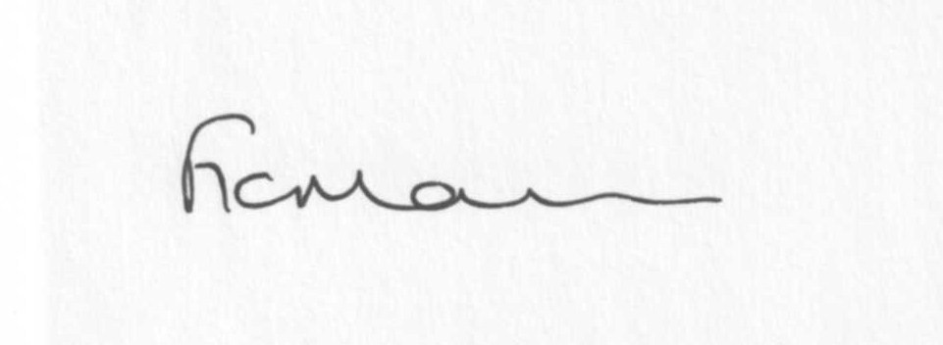
Mrs F Morris
Clerk to the Parish Council

AGENDA

0) Public participation
1) Apologies for absence
2) Declaration of Interests
The Localism Act 2011, Relevant Authorities (Disclosable Pecuniary Interests) Regulations 2012.
Members are reminded that they are required to leave the room during the discussion and voting on matters in which they have a disclosable pecuniary interest, whether or not the interest is entered in the register of member’s interests maintained by the Monitoring Officer.
3) Councillor’s dispensations
4) To confirm minutes of the meeting held on 17th December 2012 (copy attached)
5) Matters Arising from the minutes
a) Progress report (list distributed at meeting)
b) Any other matters arising
6) Planning applications:
For information only:
a) 12/05174/OHL (applicant; Western Power Distribution) - Diversion of an existing 11kv overhead single service line at Heath Farm, Burwarton .
b) 12/05186/AGR - Erection of a general purpose agricultural building at Detton site – applicant M Fletcher, Oakfield Farm, Bagginswood.
c) 12/05251/OHL (applicant WSE Freedom Group on behalf of Western Power) - To divert approx. 160m of existing HV lines to reinforce the network – Upper House Farm, Sidbury.
d) 12/05187/AGR – Erection of an agricultural building for the storage of farm machinery at the Oakfield site – applicant M Fletcher, Oakfield Farm, Bagginswood.
e) Any others received after issue of the agenda
f) Permissions/refusals
7) Shropshire Councillor’s report
8) SALC report
9) Personnel Committee report
10) Finance:
a) Accounts to be paid: Clerks fees/expenses. PAYE. Viking Direct
Any other accounts received after issue of the agenda
b) Income since last meeting
c) Bank statement/Bank reconciliation
d) Budget/precept/letter from SC re: precept
11) Parish matters/problems
a) Parish problems
b) Parish Watch
c) Bus shelter update
12) Correspondence:
Emails forwarded to Cllrs:
Rural Services Network newsletters
ALC Bulletins
Weekly Planning lists
SLCC – Council Tax capping
Shropshire Flood Insurance and Information Workshop – 24/1/13, Shirehall 5.30pm-9.00pm
Draft Police and Crime Plan and Precept Options
LJC – change of venue to Lacon Childe School 21st February 7pm
ALC Elections Information
LCR and Clerks Direct magazines
Any others received after the issue of the agenda
13) Date of next meeting – 25th February 2013

Due to the confidential nature of the business to be discussed under the Public Bodies (Admission to Meetings) Act 1960 and under s100 (A) of the Local Government Act 1972 the public and press shall be excluded for the remainder of the meeting for the following items of business on the grounds they may involve the likely disclosure of exempt information as defined by the Acts.

14) Playing Field – if any update received
15) Car parking – if any update received

