
Stottesdon and Sidbury Parish Council
Clerk: Mrs Freda Morris
18 Glebe Drive
Stottesdon
Kidderminster
Worcs
DY14 8UF

Telephone: 01746 718453
E-mail: stottesdonpc@btinternet.com

Date: 14th October 2013
To: All Parish Council members
The Public and Press

A Parish Council meeting will be held on MONDAY 21st OCTOBER 2013 at 7.30pm in CHORLEY VILLAGE HALL for the transaction of business as set out in the agenda below which you are summoned to attend.

Yours sincerely

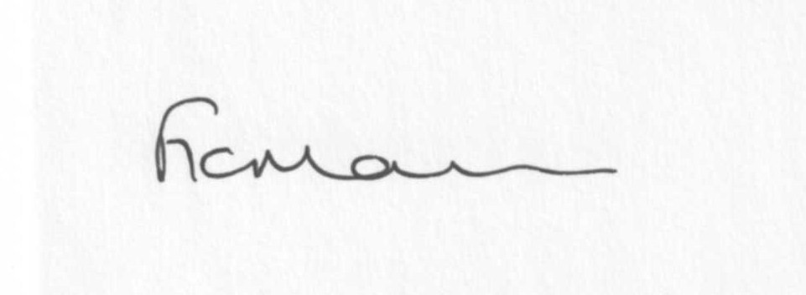

Mrs F Morris
Clerk to the Parish Council

AGENDA

0) Public participation (maximum 15 minutes)
1) Apologies for absence
2) Declaration of Interests
The Localism Act 2011, Relevant Authorities (Disclosable Pecuniary Interests) Regulations 2012.
Members are reminded that they are required to leave the room during the discussion and voting on matters in which they have a disclosable pecuniary interest, whether or not the interest is entered in the register of member’s interests maintained by the Monitoring Officer.
3) To confirm minutes of the meeting held on 16th September 2013 (copy attached)
4) Matters Arising from the minutes
(a) Progress report (distributed at meeting)
(b) School field update/letter from Headteacher
(c) Speed counter at Chorley
(d)Any other matters arising
5) Planning applications:
A) Reference: 13/03652/FUL (validated: 17/09/2013)
Address: Country Park, Rays Farm, Billingsley, Highley, Bridgnorth, Shropshire, WV16 6PF
Proposal: Extension to and alteration of existing pole barn to provide additional toilet & reception facilities and demonstration area
Applicant: Mrs J Nicholls (Rays Farm, Billingsley, Bridgnorth, Shropshire, WV16 6PF)

B) Reference: 13/03999/FUL (validated: 04/10/2013)
Address: Desert Woods, Billingsley, Highley, Bridgnorth, Shropshire
Proposal: Construction of new road - 20 year woodland management plan in place, approved in Nov 2012.
Applicant: Mr Tom Cook (Sunnyville, Chorley, Whipple Trees, Bridgnorth, Shropshire, WV16 6PP)

c) Any other plans received after issue of the agenda

d) Planning permissions/refusals:
Reference: 13/03269/FUL (validated: 22/08/2013)
Address: Lower Chorley Farm, Chorley, Bridgnorth, Shropshire, WV16 6PP
Proposal: Erection of a building for use as workshop and oak frame assembly area
Decision: Grant Permission

e) Any other permissions/refusals received after issue of the agenda

6) SALC report
7) Unitary Councillor’s report
8) Financial matters:
a) Outstanding payments: Clerks fees/HMRC PAYE, SALC training account, Account - £24 (Good Councillors Guide), £50 - Local Councils Explained Book, Viking Direct Account, Information Commissioner’s renewal.
Any others received after issue of the agenda
b) Income since last meeting - confirmed at meeting
c) Bank statement
d) Audit
e) Quarterly bank reconciliation/budget
9) Cllr Abbiss resignation letter from Stottesdon School Governors
10) To appoint new member to personnel committee/fix date for meeting
11) Parish matters/problems
a) Parish problems
b) Parish Watch
12) Correspondence:
Emails forwarded:
SALC Bulletins
Rural Services Network newsletters
New Community Bus
SALC – Annual Place Plan Review 2013-14
B4555 road closure delayed – new date to be confirmed
Electoral Roll alterations
RSN – Rural Vulnerability Service –Broadband
Update from Philip Dunne MP
Shropshire Rural Hub newsletter
SC – CIL Neighbourhood Fund
SALC - AGM
Any others received after the issue of the agenda
13) To consider Disclaimer for emails
14) Date of next meeting – 25th November 2013
15) Update: Car parking/playing field
Due to the confidential nature of the business to be discussed under item 15 the public and press shall be excluded under s1 (2) Public Bodies (Admission to Meetings) Act 1960 as amended

