
Stottesdon and Sidbury Parish Council
Clerk: Mrs Freda Morris
18 Glebe Drive
Stottesdon
Kidderminster
Worcs
DY14 8UF

Telephone: 01746 718453
E-mail: stottesdonpc@btinternet.com

Date: 15th July 2013
To: All Parish Council members
The Public and Press

A Parish Council meeting will be held on MONDAY 22nd JULY 2013 at 7.30pm in CHORLEY VILLAGE HALL for the transaction of business as set out in the agenda below to which you are summoned to attend.

Yours sincerely

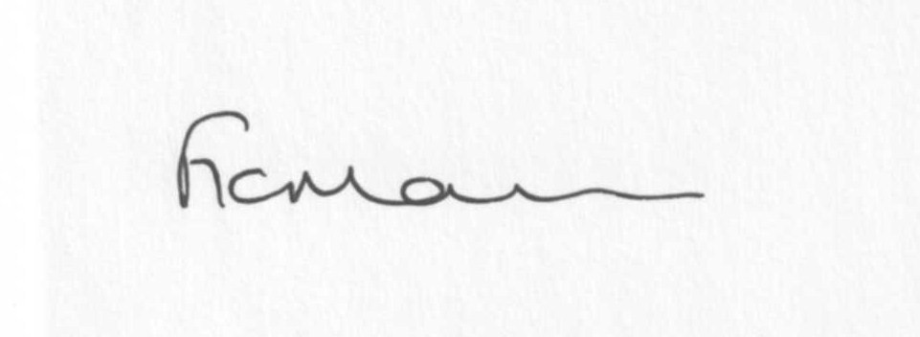

Mrs F Morris
Clerk to the Parish Council

AGENDA:

0) Public participation
1) Apologies for absence
2) Declaration of Interests:
The Localism Act 2011, Relevant Authorities (Disclosable Pecuniary Interests) Regulations 2012.
Members are reminded that they are required to leave the room during the discussion and voting on matters in which they have a disclosable pecuniary interest, whether or not the interest is entered in the register of member’s interests maintained by the Monitoring Officer.
3) To confirm minutes of the meeting held on 24th June 2103 (copy attached)
4) Matters Arising from the minutes
(a) Progress report (distributed at meeting)
(b) Reply from SC re: play area provision
(c) Reply from SC re: parish problems
(d) Update re: School bus
(e) Any other matters arising
5) Dispensations:
Requests for dispensations should be sent in writing to the Clerk prior to the meeting.
6) Co-options
7) Signing of Declarations
8) Planning applications:
a) Reference: 13/02439/FUL (validated: 03/07/2013)
Address: Timber Yard, Midwinters, Chorley, Bridgnorth, Shropshire, WV16 6PW
Proposal: Erection of steel portal agricultural building
Applicant: Home Forestry LLP (Braggins Lye, Chorley, Bridgnorth, Shropshire, WV16 6PP)

b) Any others received after issue of the agenda

c) Planning permissions/refusals:
Reference: 13/02150/OHL (validated: 31/05/2013)
Address: Mass House Farm, Stottesdon, Kidderminster, Shropshire, DY14 8NL
Proposal: Erect an 11,000 volt overhead line on wood poles
Decision: No Objection OHL/Circular Notification
9) SALC report
10) Unitary Councillor’s report
11) Financial matters:
a) Outstanding payments:
SALC account – training
Clerk’s fees/expenses
HMRC PAYE
SLCC account
Any others received after issue of the agenda.
b) Income since last meeting (confirmed at meeting)
c) Quarterly bank/budget reconciliation
d) Bank statements
12) Parish matters/problems
a) Parish problems
b) Parish Watch
13) Correspondence:
Emails forwarded:
SALC Bulletins
Shropshire Hills AONB Management Plan 2014-19 public consultation
SC – surface dressing timetable July 2013
SC – Free Trees!!
RSN Newsletters
SC – Annual Town and Parish Emergency Planning Briefing – 26/9/13, 6.30pm at Shirehall
Planning training – 1st August Parish Hall, Cleobury Mortimer
Gay Barker – Highley Patients Group newsletter
SALC – Chairmanship training - 22nd July
Complaint re: Stroll 1 – forwarded to P3 group
ROAD CLOSURE – Oreton Road junction to Honeysuckle junction, Farlow (Section 20m either side of Bombay House) - 03 September 2013 - 1 day (between 08.00 hrs and 17.00 hrs only) - Tree Cutting
Any others received after the issue of the agenda
14) Newsletter distribution
15) Date of next meeting – 19th August 2013
16) Update on parking/playing field**
**Due to the confidential nature of the business to be discussed under item 16 the public and press shall be excluded under s1 (2) Public Bodies (Admission to Meetings) Act 1960 as amended

