
Stottesdon and Sidbury Parish Council
Clerk: Mrs Freda Morris
18 Glebe Drive
Stottesdon
Kidderminster
Worcs
DY14 8UF

Telephone: 01746 718453
E-mail: stottesdonpc@btinternet.com

Date: 15th October 2012
To: All Parish Council members
The Public and Press

A Parish Council meeting will be held on MONDAY 22nd OCTOBER 2012 at 7.30pm in CHORLEY VILLAGE HALL for the transaction of business as set out in the agenda below.

Yours sincerely

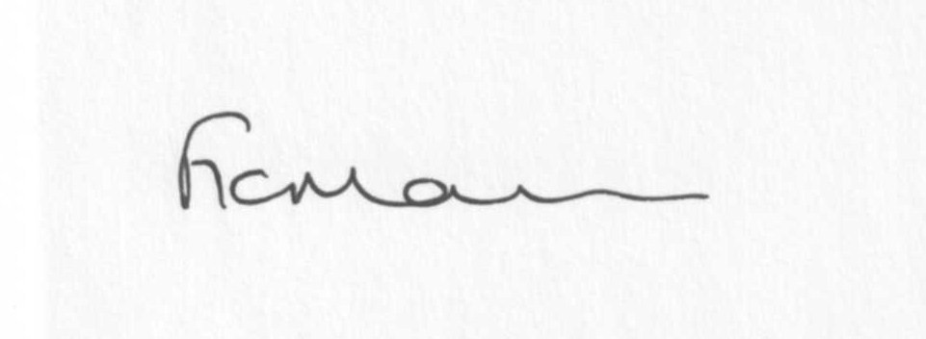

Mrs F Morris
Clerk to the Parish Council

AGENDA

0) Public participation
1) Apologies for absence
2) Declaration of Interests
The Localism Act 2011, Relevant Authorities (Disclosable Pecuniary Interests) Regulations 2012.
Members are reminded that they are required to leave the room during the discussion and voting on matters in which they have a disclosable pecuniary interest, whether or not the interest is entered in the register of member’s interests maintained by the Monitoring Officer.
3) To confirm minutes of the meeting held on 24th September 2012 (copy attached)
4) Matters Arising from the minutes
(a) Progress report (list distributed at meeting)
(b) Any other matters arising
5) Planning applications:
a) Replace single storey garage with two storey extension and erection of a single storey rear
garden room – 4 High Street, Stottesdon. App. No: 12/03987/FUL
b)Erection of replacement dwelling following demolition of existing – Tanglewood, Midwinters,
Chorley. App. No: 12/02981/FUL
c) Any others received after issue of agenda
d) Permissions: Erection of a portal framed livestock building – Pickthorn Farm, Chorley
6) Parish matters/problems
a) Parish problems
b) Parish Watch
7) Community Shop
8) SALC report
9) Shropshire Councillor’s report
10) Financial matters
a) Outstanding payments:
Clerks salary/expenses
Viking Direct account (ink cartridges etc)
Bus Shelter repair account
Information Commissioner’s Office renewal
Audit fee
Any others received after issue of agenda
b) Income since last meeting (list distributed at meeting)
c) Bank statement
d) Quarterly bank/budget reconciliation
e) Audit
11) Speed Management consultation document
12) Correspondence:
Including emails forwarded to Councillors:
Western Power Distribution Workshop – future investment plans
St Mary’s Church Christmas tree festival
25/9 RSN newsletter
26/9 SC –change of date for roadworks at Brooksmeeting
28/9 Weekly planning list
28/9 SALC Information Bulletin
1/10 RSN newsletter
2/10 SALC –Place Plan Reviews
3/10 RSN newsletter
3/10 Tower Mint – Commemorative Coronation medals
5/10 Weekly planning list
8/10 RSN newsletter
8/10 Tracy Johnson – Place Plan/CIL workshop presentation and notes
8/10 Cleobury and Rural LJC meeting 23/10/12 Milson and Neen Sollars Victory Hall 7pm
8/10 SALC Information Bulletin
9/10 Shropshire North against pylons (SNAP)
10/10 SALC AGM
11/10 Keith Barrow – National Grid Mid Wales Connection project
11/10 SC –Post 16 College and 6th form assistance for entitled students – consultation on arrangements for September 2013
11/10 SALC AGM booking forms
12/10 Came and Company Insurance newsletter
12/10 Weekly planning list
12/10 SC – resurfacing Oldfield Lane 19th October 2012
12/10 SALC Information Bulletin
15/10 RSN newsletter
Any others received after issue of the agenda
13) Date of next meeting - November 26th 2012

