
Stottesdon and Sidbury Parish Council
Clerk: Mrs Freda Morris
18 Glebe Drive
Stottesdon
Kidderminster
Worcs
DY14 8UF

Telephone: 01746 718453
E-mail: stottesdonpc@btinternet.com

Date: 15th February 2015
To: All Parish Council members
The Public and Press

A Parish Council meeting will be held on MONDAY 23rd FEBRUARY 2015 at 7.30pm in CHORLEY VILLAGE HALL for the transaction of business as set out in the agenda below which you are summoned to attend.

Yours sincerely
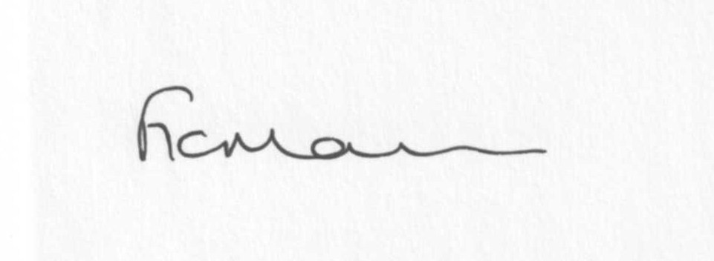
Mrs F Morris
Clerk to the Parish Council

AGENDA

0) Public participation (maximum 15 minutes)
1) Apologies for absence
2) Declaration of Interests
The Localism Act 2011, Relevant Authorities (Disclosable Pecuniary Interests) Regulations 2012.
Members are reminded that they are required to leave the room during the discussion and voting on matters in which they have a disclosable pecuniary interest, whether or not the interest is entered in the register of member’s interests maintained by the Monitoring Officer.
3) To confirm minutes of the meeting held on January 26th 2014 (copy attached)
4) Matters Arising from the minutes
(a) Progress report (distributed at meeting)
(b) Reply from SC re: parish problems
(c) Reply from Insurance Company re: Glebe Drive parking
(d)Any other matters arising

5) Planning applications:
a) Amendments to application no: 14/03842/FUL – Use of land for the stationing of 6 log cabins for a mix of holiday lets and accommodation for rehabilitation centre clients – Stanley Farm, Chorley

b) Reference: 15/00179/FUL (validated: 14/01/2015)
Address: Brooklands Cottage, Farlow, Bridgnorth, Kidderminster, Shropshire, DY14 8TA
Proposal: Erection of a detached double garage with playroom over
Applicant: Mr & Mrs William Clulee

c) Any others received after issue of agenda
d) Planning permissions/refusals- if any received after issue of agenda
6) SALC report
7) Unitary Councillor’s report
8) Financial matters:
a) Outstanding payments: Clerks fees/HMRC PAYE, Parish Online renewal (£33.60), Willowdene Resources (Lengthsman scheme account)
Any others received after issue of the agenda
b) Income since last meeting - confirmed at meeting
c) Bank statement
d) Bank accounts
9) Parish matters/problems
a) Parish problems
b) Parish Watch
10) Correspondence:
Emails forwarded include:
SALC Bulletins
RSN newsletters
SC – Precept request confirmation
SC – Road closure Chorley – 16-18th March 8.00am – 5.00pm
SC – Acknowledgement of letter from Keith Barrow re: CTSG
SC – Severe Weather/potholing schemes
SC – Electoral Roll updates
Update from Philip Dunne, MP
SALC – Karen Roper resignation
SC – Reply to email from resident
Any others received after issue of agenda

Reminder of Forthcoming road closures:
Road to be closed: Walkerslow Bridge - Overton Junction to the Baytree junction, Burwarton, Shropshire
Date and duration: 02/03/2015 - 4 days (08.00 - 16.00)
Purpose: Bridge Maintenance Works
Applicant: Ringway

Road to be closed: Honeysuckle Junction to The Miners Junction, Stottesdon, Shropshire
Date and duration: 23/02/2015 for 4 days (09.30 - 16.00)
Purpose: Carriageway Resurfacing
Applicant: Ringway

Road to be closed: New Road, Highley
Date: 7th February 2015 for 16 days
(7th and 8th Feb closure 08.00 to 18.00, 14th – 22nd Feb closure 24 hours)
Applicant: Ringway on behalf of Shropshire Council

Road to be closed: Ferney Hall to Yew Tree junction, Chorley
Date: 16th March 2015 – 18th March 2015 9.8.00 to 17.00)
Purpose: Carriageway resurfacing
Applicant: Ringway on behalf of Shropshire Council
Any others received after issue of the agenda
11) Date of next meeting: 23rd March 2015
12) Update: Car parking/playing field ** - if anything to report.
**Due to the confidential nature of the business to be discussed under item 13 the public and press shall be excluded under s1 (2) Public Bodies (Admission to Meetings) Act 1960 as amended

