
Stottesdon and Sidbury Parish Council
Clerk: Mrs Freda Morris
18 Glebe Drive
Stottesdon
Kidderminster
Worcs
DY14 8UF

Telephone: 01746 718453
E-mail: stottesdonpc@btinternet.com

Date: 17th March 2013
To: All Parish Council members
The Public and Press

A Parish Council meeting will be held on MONDAY 25th March 2013 at 7.30pm in CHORLEY VILLAGE HALL for the transaction of business as set out in the agenda below, which you are summoned to attend.

Yours sincerely

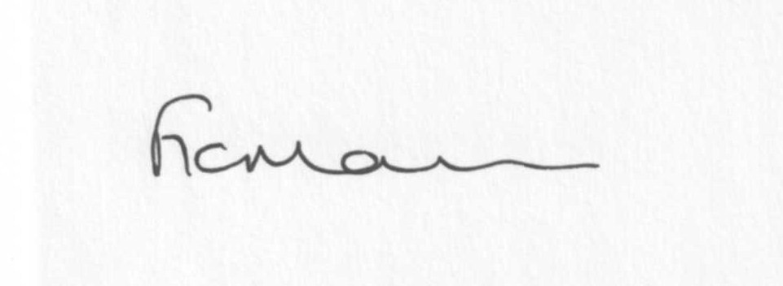

Mrs F Morris
Clerk to the Parish Council

AGENDA

0) Public participation
1) Apologies for absence
2) Declaration of Interests
The Localism Act 2011, Relevant Authorities (Disclosable Pecuniary Interests) Regulations 2012.
Members are reminded that they are required to leave the room during the discussion and voting on matters in which they have a disclosable pecuniary interest, whether or not the interest is entered in the register of member’s interests maintained by the Monitoring Officer.
3) Councillor’s dispensations
4) To confirm minutes of the meeting held on 25th February 2013 (copy attached)
5) Matters Arising from the minutes
(a) Progress report (distributed at meeting)
(b) Any other matters arising
6) Planning applications:
a) Reference: 13/01001/TCA (validated: 15/03/2013)
Address: Chapel House , 4 Station Road, Stottesdon, Kidderminster, DY14 8TT
Proposal: To crown clean and crown thin by up to 20% 1No. Beech and to crown reduce by 25% 1No. Sycamore within Stottesdon Conservation Area
Applicant: Mrs Alison Parsons (4 Station Road, Stottesdon, DY14 8TT)

FOR INFORMATION ONLY
Reference: 13/00926/AGR
Development proposed: Proposed agricultural building to store grain and machinery
Location: Land North West of Walton Farm, Stottesdon
OS Reference: 367121 – 281226
Applicant: Mr Stephen Howells

b) Any others received after issue of agenda
c) Planning permissions/refusals
7) Financial matters
a) Outstanding payments:
Clerks fees/expenses. Viking Direct a/c. Chorley Village Hall a/c. Crucial Crew a/c.
Tim Preece Builders (bus shelter). Chorley Family Playgroup. HMRC PAYE.
Any others received after issue of agenda.
To invoice SC for grant for bus shelter.
Confirmation to add to insurance.
Donation requests:
Samaritans, Severn Hospice, CAB, Hope House.
Any others received after issue of agenda.
b) Income since last meeting (list distributed at meeting)
c) Asset Register
d) Risk Assessment
8) SALC report
9) Shropshire Councillor’s report
10) Elections
11) Correspondence:
Letter re: Bridleway clearance
Letter from Chorley Playgroup re: donation
Emails forwarded to all Cllrs:
RSN newsletters
SALC Bulletins
Weekly Planning lists
Came & Co Spring newsletter
Community Use of School Playing field
Bridgnorth/Cleobury Mortimer road closure – 25th March (1 week) – rescheduled work
Reflector Posts – Hawkswood Lane complaint
Lower Severn Corridor Flood Forum meeting, - Westgate, 22nd April 2pm
Any others received after the issue of the agenda
12) Parish matters/problems
a) Parish problems
b) Parish Watch
13) Date of next meeting:
15th April (Annual Parish meeting) 22nd April 2013 (Parish Council meeting)

Due to the confidential nature of the business to be discussed under the Public Bodies (Admission to Meetings) Act 1960 and under s100 (A) of the Local Government Act 1972 the public and press shall be excluded for the remainder of the meeting for the following items of business on the grounds they may involve the likely disclosure of exempt information as defined by the Acts.

14) Parking – any update received
15) Playing field – any update received

