
Stottesdon and Sidbury Parish Council
Clerk: Mrs Freda Morris
18 Glebe Drive
Stottesdon
Kidderminster
Worcs
DY14 8UF

Telephone: 01746 718453
E-mail: stottesdonpc@btinternet.com

Date: 18th November 2012
To: All Parish Council members
The Public and Press

A Parish Council meeting will be held on MONDAY 26th November 2012 at 7.30pm in CHORLEY VILLAGE HALL for the transaction of business as set out in the agenda below.

Yours sincerely

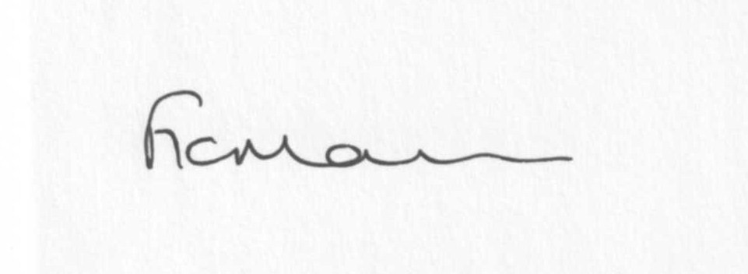
Mrs F Morris
Clerk to the Parish Council

AGENDA

0) Public participation
1) Apologies for absence
2) Declaration of Interests
The Localism Act 2011, Relevant Authorities (Disclosable Pecuniary Interests) Regulations 2012.
Members are reminded that they are required to leave the room during the discussion and voting on matters in which they have a disclosable pecuniary interest, whether or not the interest is entered in the register of member’s interests maintained by the Monitoring Officer.
3) To confirm minutes of the meeting held on 22nd October 2012 (copy attached)
4) Matters Arising from the minutes
a) Progress report (list distributed at meeting)
b) Any other matters arising
5) Planning applications:
a) Conversion of 2 redundant farm buildings to 4 residential units – Upper Northwood Farm,
Northwood Lane, Stottesdon – app. No: 12/04279/FUL
b) Any others received after issue of the agenda
c) Permissions/refusals
6) Shropshire Councillor’s report
7) SALC report
8) Verbal report from Personnel Committee
9) Dispensations for Councillors
10) Finance:
a) Accounts to be paid: Clerks fees/expenses/coins for heating at Village Hall
Lengthsman Scheme account
Burial grants – Stottesdon/Sidbury/Chorley
Any other accounts received after issue of the agenda
b) Income since last meeting
c)Budget/precept
11) Parish matters/problems
a) Parish problems
b) Parish Watch
c) Lengthsman Scheme
12) Correspondence:
Emails forwarded to Cllrs:
24/10 SC - Walkerslow Bridge road closure 19th November for 3 weeks
26/10 ALC – ICT support for Parish and Town Councils
29/10 River Teme Pilot Partnership community Event
31/10 Bus Shelter quotes
2/11 ALC – Bulletin
7/11 SC – Lower Severn Corridor Minutes of meeting 11/10/12
12/11 SC – Speed Management consultation
14/11 ALC – SamDev Position Statement and update Place Plans/CIL
16/11 Linda Jeavons - River Teme Pilot community event
Weekly Planning Lists
Rural Service Network newsletters
Anonymous letter re: hedge at Bagginswood
Country Treks letter re: bridleways
CAB – donation request
Any others received after the issue of the agenda
13) Date of next meeting - 17th December 2012

Due to the confidential nature of the business to be discussed under the Public Bodies (Admission to Meetings) Act 1960 and under s100(A) of the Local Government Act 1972 the public and press shall be excluded for the remainder of the meeting for the following items of business on the grounds they may involve the likely disclosure of exempt information as defined by the Acts.

14) Playing Field
15) Car parking

