
Stottesdon and Sidbury Parish Council
Clerk: Mrs Freda Morris
18 Glebe Drive
Stottesdon
Kidderminster
Worcs
DY14 8UF

Telephone: 01746 718453
E-mail: stottesdonpc@btinternet.com

Date: 18th September 2011
To: All Parish Council members
The Public and Press

A Parish Council meeting will be held on MONDAY, SEPTEMBER 26th at 7.30pm in CHORLEY VILLAGE HALL for the transaction of business as set out in the agenda below.

Yours sincerely

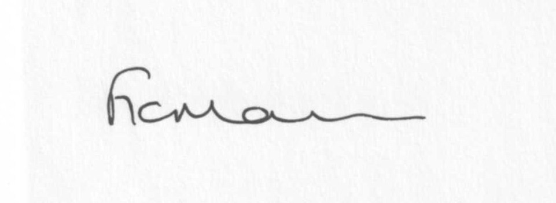
Mrs F Morris
Clerk to the Parish Council

AGENDA

0) Public participation
1) Apologies for absence
2) Chairman’s resignation
3) Election of Chairman/signing of declaration
4) Declaration of Interests
“To receive declarations of Interest of personal and prejudicial interest on any item on the agenda in accordance with Section 50-52 of the Local Government Act & The Local Authorities (Model Code of Conduct) England Order 2001”.
5) To confirm minutes of the meeting held on 22nd August 2011(copy attached)
6) Matters Arising from the minutes
(a) Progress report (list distributed at meeting)
7) Planning applications:
a) Erection of a garage – Rose Cottage, Bakehouse Lane, Chorley
b) Any others received after issue of agenda
c) Permissions – Lower Chorley Farm, Heath Farm, Bagginswood.
Any others received after issue of agenda.
8) Correspondence:
SC – ‘No through road’ sign – Bakehouse Lane, Chorley
See attached email list.
Any others received after the issue of the agenda
9) Parish matters/problems
a) Parish problems
b) Parish Watch
c) Parish Plan update
10) Financial matters
a) Outstanding payments - Clerk’s fees. Any other accounts received after issue of agenda.
b) Income since last meeting (list distributed at meeting)
c) Bank signatories
11) Shop update
12) Diamond Jubilee
13) Road Name signs
14) ALC report
15) Shropshire Councillor’s report
16) Items for next agenda
17) Date of next meeting - 24th October 2011

