
Stottesdon and Sidbury Parish Council
Clerk: Mrs Freda Morris
18 Glebe Drive
Stottesdon
Kidderminster
Worcs
DY14 8UF

Telephone: 01746 718453
E-mail: stottesdonpc@btinternet.com

Date: 20th February 2012
To: All Parish Council members
The Public and Press

A Parish Council meeting will be held on MONDAY 27th February 2012 at 7.30pm in CHORLEY VILLAGE HALL for the transaction of business as set out in the agenda below which you are summoned to attend.

Yours sincerely
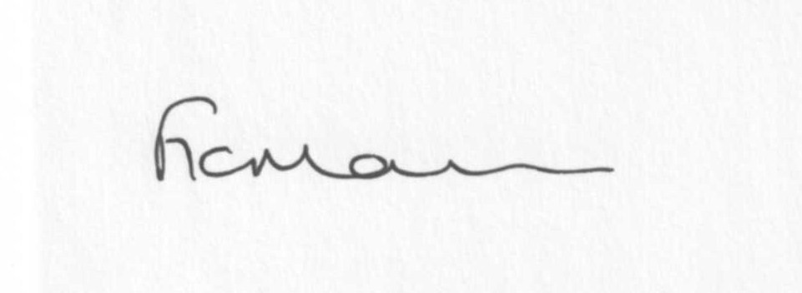
Mrs F Morris
Clerk to the Parish Council

AGENDA

0) Public participation
1) Apologies for absence
2) Declaration of Interests
“To receive declarations of Interest of personal and prejudicial interest on any item on the agenda in accordance with Section 50-52 of the Local Government Act & The Local Authorities (Model Code of Conduct) England Order 2001”.
3) To confirm minutes of the meeting held on January 23rd 2012 (copy attached)
4) Matters Arising from the minutes
(a) Progress report
(b) Any other matters arising
5) Planning applications:
a) Demolition, removal and re-building of front boundary wall topped with railings to a height of 1.4m – Manor House, The Square, Stottesdon
b) Any others received after issue of agenda
c) Planning permissions granted
d) Site visit – Bradley Cottage, Bagginswood
6) Parish Plan update
7) Update from Stanley Farm
8) Playgroup project update including advice from Legal Dept, NALC.
9) Stotty Shop update
10) Correspondence:
SC – ‘local connection’ confirmation request.
ALC – Looking to the future – Shropshire/Telford NHS Trust newsletter
Fields in Trust – how is your PC going to celebrate the Queen’s Diamond Jubilee
Weekly planning lists
Cllr M Price – SAMDev
Rural Services Network newsletters
Cllr Butler – ‘Terms of Reference’ as an alternative to a Charter
Came and Co Insurance – Winter warning
Historic Towns Forum
Email request to update minutes on website
CIL/Place Plan briefing invitation 9th March, Westgate, 2pm
Cleobury and Rural LJC
ALC – ITC Services for Parish and Town Councils
ALC – Proposed Arms Length Management Organisation (ALMO)
ALC Bulletins
ALC – Important consultation – see email dated 16th February
South Shropshire housing Group – invitation to Ludlow Food Centre 16th March 3-6pm (if PC interested in providing homes within the parish).
TCPA latest seminars – Planning for growth (19th March) and Taking Stock of planning reform (4th April) both in London.
Any others received after issue of the agenda
11) Parish matters/problems
a) Parish problems
b) Parish Watch
12) Financial matters
a) Outstanding payments - Clerk’s fees/expenses. Parish Online renewal fee. Account for Jubilee coins. HMRC/PAYE. Donation request from Samaritans. Any others received after issue of agenda
b) Income since last meeting/bank statement
c) Additional bank signatory
d) Receipt from Crucial Crew donation
13) ALC report
14) Shropshire Councillor’s report
15) Items for next agenda
16) Date of next meeting – 26th March 2012 (this date clashes with Accounts training session)

