
Stottesdon and Sidbury Parish Council
Clerk: Mrs Freda Morris
18 Glebe Drive
Stottesdon
Kidderminster
Worcs
DY14 8UF
E-mail: stottesdonpc@btinternet.com

Date: 21st March 2011
To: All Parish Council members
The Public and Press

A Parish Council meeting will be held on MONDAY 28th MARCH 2011 at 7.30pm in CHORLEY VILLAGE HALL for the transaction of business as set out in the agenda below.

Yours sincerely

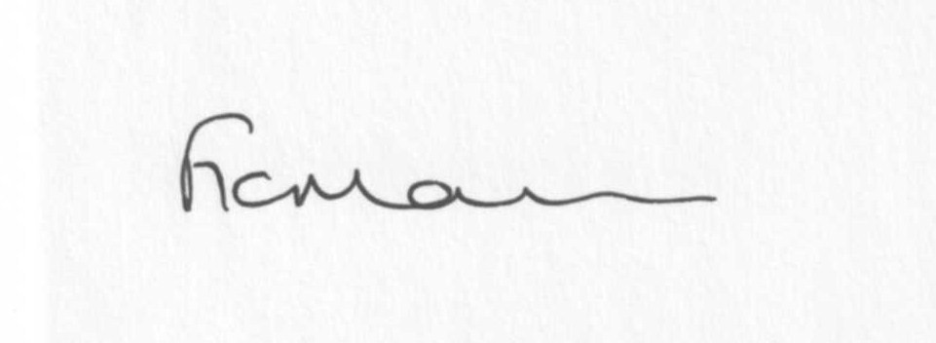

Mrs F Morris
Clerk to the Parish Council

AGENDA

0) Public participation
1) Apologies for absence
2) Declaration of Interests
“To receive declarations of Interest of personal and prejudicial interest on any item on the agenda in accordance with Section 50-52 of the Local Government Act & The Local Authorities (Model Code of Conduct) England Order 2001”.
3) To confirm minutes of the meeting held on 28th February 2011(copy attached)
4) Matters Arising from the minutes
(a) Progress report (distributed at meeting)
(b) Any matters raised by Councillors from minutes
5) Planning applications: a) Construction of a new vehicular access – Walnut Tree Cottage,
4 Midwinters, Chorley.
b) Any others received after issue of agenda
c) Permissions/refusals
d) To confirm applications: 1) Replace entrance doors and various windows
affecting a Grade II Listed Building – Lower
Chorley Farm, Chorley
2) To cut back overgrowing branches of one
Silver Birch tree with Stottesdon Conservation Area – The Rectory, Stottesdon

6) Correspondence:
LCR magazine
WM Ambulance Service reply
SC – Future Education in Shropshire posters
Bank statement
Concept – Localism Bill – Neighbourhood Plans & N/hood Development Orders (Copy attached)
Letter from MP P Dunne re: Localism Bill (precept) – copy attached
ALC – The Good Councillor’s Guide and Parish Matters newsletter from Came and Co.
Emails:
Planning application notifications weekly
Rural Services Network newsletters
SC – Road closure – Dingle Bridge, Middleton Scriven
Localism Bill – What Parish Council’s really need to know
CiNCH roadshows – ‘It’s in your hands’
ALC – Employment Briefing
SC – New Public Access System for Shropshire website links
Mobile Library changes
Cleobury & Rural LJC funding application deadline
ALC – NALC DIS54 Round Up
Brown Clee Medical PPG newsletter delivery request
Mr Upton – Speeding traffic through Chorley
Public Service Efficiency update
Shropshire Olympian Festival update
ALC – Developer Contributions and the community Infrastructure Levy
ALC – PB Event
ALC – Larger councils meeting
ALC – Account and Audit regulations update
Any others received after the issue of the agenda
7) Parish matters/problems
a) Parish problems
b) Parish Watch
8) Financial matters
a) Outstanding payments - Clerk’s fees/expenses. PAYE. Crucial Crew. N/Letter. PC Online.
Lengthsman Scheme account. Any others received .
To consider donation requests: Severn Hospice, Hope House, CAB, No Panic. Any others received.
b) Income since last meeting (distributed at meeting)
9) Stottesdon School field drainage
10) Website policy
11) Risk Assessment
12) Street name signs
13) ALC report
14) Shropshire Councillor’s report
15) Items for next agenda
16) Date of next meeting - Annual Parish Meeting 11th April – Rays Farm, Billingsley 7.30pm

