
Stottesdon and Sidbury Parish Council
Clerk: Mrs Freda Morris
18 Glebe Drive
Stottesdon
Kidderminster
Worcs
DY14 8UF

Telephone: 01746 718453
E-mail: stottesdonpc@btinternet.com

Date: 30th April 2013
To: All Parish Council members
The Public and Press Please note change of venue

An extra-ordinary meeting is to be held on TUESDAY 7th MAY 2013 at 7.30pm in STOTTESDON CHURCH for the transaction of the business as set out in the agenda below which you are summoned to attend

Yours sincerely

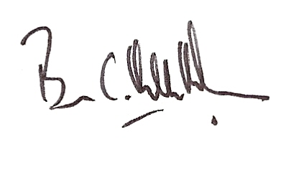

Brian Hamilton-Russell
Chairman - Parish Council

AGENDA

0. Parishioner’s time
1. Declarations of acceptance of Office
2. Declaration of interests:
The Localism Act 2011, Relevant Authorities (Disclosable Pecuniary Interests) Regulations 2012.
Members are reminded that they are required to leave the room during the discussion and voting on matters in which they have a disclosable pecuniary interest, whether or not the interest is entered in the register of member’s interests maintained by the Monitoring Officer.
3. Planning application:
Planning reference: 13/00450/FUL
Development proposed: Erection of an agricultural building to service proposed orchard development and house agricultural equipment
Location: Pool Meadow Orchard, Harcourt Lane, Stottesdon, Shropshire, DY14 8UQ
Applicant: Mr P Datlen

