
Stottesdon and Sidbury Parish Council
Clerk: Mrs Freda Morris
18 Glebe Drive
Stottesdon
Kidderminster
Worcs
DY14 8UF

Telephone: 01746 718453
E-mail: stottesdonpc@btinternet.com

Date: 17th January 2010
To: All Parish Council members
The Public and Press

A Parish Council meeting will be held on MONDAY 25th JANUARY 2010 at 7.30pm in CHORLEY VILLAGE HALL for the transaction of business as set out in the agenda below.

Due to the confidential nature of the business to be discussed under item 10 the public and press shall be excluded under s1(2) Public Bodies (Admission to Meetings) Act 1960.

Yours sincerely
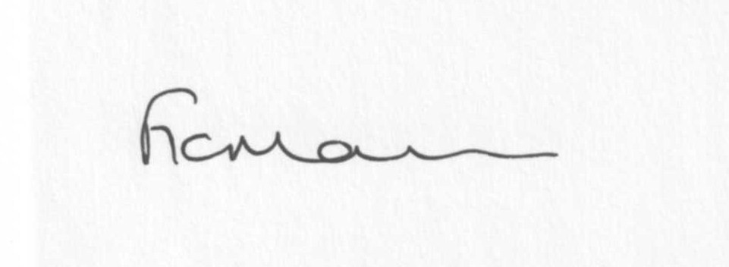
Mrs F Morris
Clerk to the Parish Council

AGENDA

0) Public participation
1) Apologies for absence
2) Declaration of Interests
“To receive declarations of Interest of personal and prejudicial interest on any item on the agenda in accordance with Section 50-52 of the Local Government Act & The Local Authorities (Model Code of Conduct) England Order 2001”.
3) To confirm minutes of the meeting held on 21st December 2009(copy attached)
4) Matters Arising from the minutes
(a) Progress report (distributed at meeting)
Reply from Chorley Village Hall re: hire costs
Reply from School re equipment inspection
Receipt Burial Grants: Sidbury and Chorley
Any others
5) Planning applications: If any received after issue of agenda
6) Correspondence:
Emails forwarded:
Planning application lists
SC - The Parish Charter –comments for meeting please
Veolia collections
SALC Constitution Document
SALC Parish Pump
SC – Road closure Oldfield/Wrickton – Winterburn Bridge
MP – ‘Rural drivers face fuel station fall-out’
SALC – Night Time Economy
Sustainable Communities
Parish On line newsletter
William Inman – Rural Services Network
SALC- E-Bulletin
SALC – Buckingham Palace Garden Party Invitation
_________________________________________
SC Review of Public Conveniences
Severn Centre events
SALC Chairmanship Training
SC – Electoral Roll received
Any others received after the issue of the agenda
7) Parish matters/problems
a) Parish problems
b) Parish Watch
c) Parish Plan
8) Financial matters
a) Outstanding payments: Clerk’s fees and expenses; Accounts received after issue of agenda.
b) Income since last meeting (list distributed at meeting)
c) Quarterly Bank reconciliation
d) Room hire charges for future meetings
9) SALC report
10) Extra car parking
11) Shropshire Councillor’s report
12) Items for next agenda
13) Date of next meeting – 22nd February 2010

