
Stottesdon and Sidbury Parish Council
Clerk: Mrs Freda Morris
18 Glebe Drive
Stottesdon
Kidderminster
Worcs
DY14 8UF

Telephone: 01746 718453
E-mail: stottesdonpc@btinternet.com

Date: 16th March 2010
To: All Parish Council members
The Public and Press

A Parish Council meeting will be held on WEDNESDAY 24th MARCH 2010 at 7.30pm in CHORLEY VILLAGE HALL for the transaction of business as set out in the agenda below.

Yours sincerely

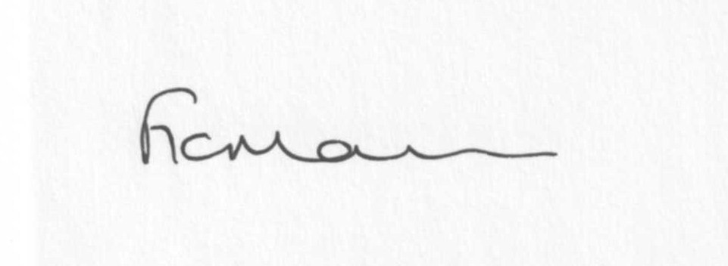

Mrs F Morris
Clerk to the Parish Council

AGENDA

0) Public participation
1) Apologies for absence
2) Declaration of Interests
“To receive declarations of Interest of personal and prejudicial interest on any item on the agenda in accordance with Section 50-52 of the Local Government Act & The Local Authorities (Model Code of Conduct) England Order 2001”.
3) To confirm minutes of the meeting held on 22nd February 2010(copy attached)
4) Casual Vacancy – to co-opt new councillor
5) Matters Arising from the minutes
(a) Progress report: SC – road repairs etc.
6) Planning applications:
a) Erection of a replacement timber framed garage with storeroom following the demolition
of existing – Lower Harcourt, Chorley, Bridgnorth.
b) Any others received after issue of agenda
c) Appeal date: Thursday 6th May – The Firs, Chorley
7) Correspondence:
Clerk’s new tax code
The Clerk magazine
LCR magazine
HM Revenue and Customs – new cd rom
SC – Updated Members Interest Form – Cllr Griffiths
Wet Midland Airport Action Group
SC – campaign to encourage people to vote
Clerk and Council’s Direct magazine
Marshalls – Driveway designs
Green Communities
Public Works Loan Board – Direct Debit notification
Crucial Crew funding request
Letter re: parking problem
Wicksteed Playscapes brochure
SLCC – Playground Safety seminar – Hereford 20th April 2010
SC – Road Closure – Prescott road – 19th April for 5 days

Emails forwarded:
Planning Lists – various
Southern Area Partnership Event
24.2.10 – LJC Ludlow & Clee re: Health Care facilities for the 21st Century
3.3.10 – RSS Update
5.3.10 – MP – New age for agriculture
5.3.10 – SALC – LJC Summit
5.3.10 – Parish News from Rural Services Network
16.3.10 – SALC – E.Bulletin
Any others received after the issue of the agenda
8) Core Strategy
9) Standing Orders/Asset Register/Risk Assessment
10) Parish matters/problems
a) Parish problems
b) Parish Watch
c)Parish Plan
11) Financial matters
a) Outstanding payments: Clerks fees/expenses; PAYE; Playgroup; Donations; Lengthsman
Scheme Account; Any others received after issue of the agenda
b) Income since last meeting (list distributed at meeting)
c) Bank statement
12) SALC report
13) Shropshire Councillor’s report
14) Items for next agenda
15) Date of next meeting – 19th April – Annual Parish Meeting

Deadline for newsletter 3rd April 12 noon!!
Please email information a.s.a.p. as these need to be delivered prior to the Annual Parish Meeting on
19th April 2010.

