STOTTESDON AND SIDBURY PARISH COUNCIL
The ANNUAL PARISH MEETING will be held at the Rays Farm Country Matters, Billingsley on MONDAY APRIL 11th 2011 at 7.30pm.
Local Government electors for the Parish will be entitled to vote at the meeting which will be open to the public.

Mr Frank Cartwright from Rays Farm Country Matters will give a presentation regarding Rays Farm.

Agenda:

01. Apologies
02. Mr Frank Cartwight, Rays Farm Country Matters
03. Minutes of last meeting – April 19th 2010 (copy attached)
04. Matters arising from minutes:
Dog fouling – update given at meeting
Speeding vehicles – update given at meeting
05. Chairman’s Annual Report
06. Organisation reports:
a) Stottesdon School Governors b) WI
c) Charity Trustees d) Playgroup
e) Chorley Village Hall f) Parish Watch
g) SWAG h) Parish Plan update i) Stotty Strolls j) Nightingale Nurses
07. Parish problems
08. Shropshire Councillor’s report
09. Chairman’s closing comments
10. Date of next meeting

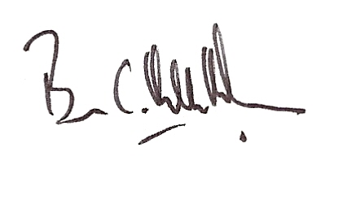
Brian Hamilton-Russell
Chairman – Stottesdon and Sidbury Parish Council

2nd April 2010

