STOTTESDON AND SIDBURY PARISH COUNCIL
The ANNUAL PARISH MEETING will be held at the CHORLEY VILLAGE HALL on MONDAY APRIL 15th 2013 at 7.30pm.
Local Government electors for the Parish will be entitled to vote at the meeting which will be open to the public.

Agenda:

01. Apologies
02. Minutes of last meeting – April 16th 2012 (copy attached)
03. Matters arising from minutes:
04. Chairman’s Annual Report
05. Shropshire Councillor’s report reports will not be given
06. Organisation reports:
a) Stottesdon School Governors
b) WI
c) Stotty Shop
d) Playgroup
e) Chorley Village Hall
f) Parish Watch
g) SWAG
h) Stotty Strolls
i) Nightingale Nurses
j) Stottesdon/Sidbury Church
k) Chorley Chapel
07. Parish problems
08. Election update
09. Chairman’s closing comments
10. Date of next meeting – April 22nd (Parish Council meeting)

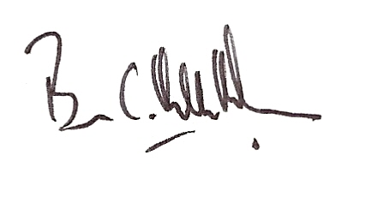
Brian Hamilton-Russell
Chairman – Stottesdon and Sidbury Parish Council

4th April 2013

