
Stottesdon and Sidbury Parish Council
Clerk: Mrs Freda Morris
18 Glebe Drive
Stottesdon
Kidderminster
Worcs
DY14 8UF

Telephone: 01746 718453
E-mail: stottesdonpc@btinternet.com

Date: 14th December 2009
To: All Parish Council members
The Public and Press

A Parish Council meeting will be held on MONDAY 21st December 2009 at 7.30pm in CHORLEY VILLAGE HALL for the transaction of business as set out in the agenda below.

Yours sincerely

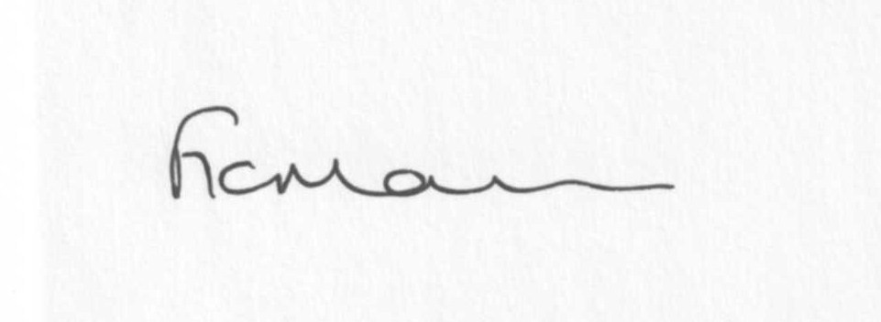
Mrs F Morris
Clerk to the Parish Council

Due to the confidential nature of the business to be discussed under item 14 the public and press shall be excluded under s1(2) Public Bodies (Admission to Meetings) Act 1960.

AGENDA

0) Public participation
1) Apologies for absence
2) Declaration of Interests
“To receive declarations of Interest of personal and prejudicial interest on any item on the agenda in accordance with Section 50-52 of the Local Government Act & The Local Authorities (Model Code of Conduct) England Order 2001”.
3) To confirm minutes of the meeting held on 23rd November 2009(copy attached)
4) Matters Arising from the minutes
(a) Progress report (list distributed at meeting)
Certificates received for Power of Well Being Qualification for Councillors
Reply from C Tibbits – Chorley Village Hall
Reply from SC re: The Firs
Litter bins
Acknowledgment from SC re: Broadplace closure
Any others
5) Planning applications:
a) Prior notification of an agricultural building for the purpose of storage – Hardwicke Farm, Stottesdon
b) Conversion of existing redundant cruck barn into residential dwelling – Lower Chorley Farm,
Chorley.
c) Internal and external alterations in connection with conversion of disused cruck barn into residential dwelling affecting a Grade II listed building – Lower Chorley Farm, Chorley.
d) Erection of an agricultural grain store – Lower Overton Farm, Middleton Scriven.
e) Any others received after issue of agenda.
6) Correspondence:
SC – Emergency Planning briefing 2nd February 2010 7pm Shirehall
LJC Meeting – Kinlet Village Hall 13th January 2010 7pm (6.30pm for Police drop-in surgery)
Emails forwarded:
26.11.09 – Sustainable Communities Act
27.11.09 – Saturday Morning Bus service – Cleobury Mortimer/Bridgnorth via Stottesdon
1.12.09 – Changes to waste collection during Christmas and New Year
1.12.09 – Training events – Chairmanship and Councillors to ascertain interest in cluster events
SLCC Newsletter
National Training Strategy On line survey
SALC Constitutional Review group meetings
Any others received after the issue of the agenda
7) Precept – papers distributed last month
8) Cultural Strategy
9) Adoption of Power of Well Being
10) Parish matters/problems
a) Parish problems – Dog mess, Station Road, Stottesdon (further complaints)
b) Parish Watch
c) Parish Plan
11) Financial matters
a) Outstanding payments: SALC training account; Clerk’s fees; Burial Grants; Any others received after issue of agenda.
b) Income since last meeting (list distributed at meeting)
c) Request for funding from Chorley Family Playgroup
12) SALC report
13) Shropshire Councillor’s report
14) Extra car parking
15) Items for next agenda
16) Date of next meeting – 25th January 2010

Newsletter Items:
Please let me have these by 4th January 2010 12 noon latest!!
Any lengthy articles will be reduced if space is limited.

