Stottesdon and Sidbury Parish Council

To: Personnel Committee members:

A Personnel meeting will be held following the Parish Council meeting on the 24th August 2015 which you are summoned to attend.

Due to the confidential nature of the business to be discussed the public and press shall be excluded under s1(2) Public Bodies (Admission to Meetings) Act 1960.

Agenda:

1. Election of Chairman and Vice Chairman
2. Apologies
3. Minutes of last meeting (forwarded separately)
4. Clerks appraisal
5. Clerks salary
6. Any other matters

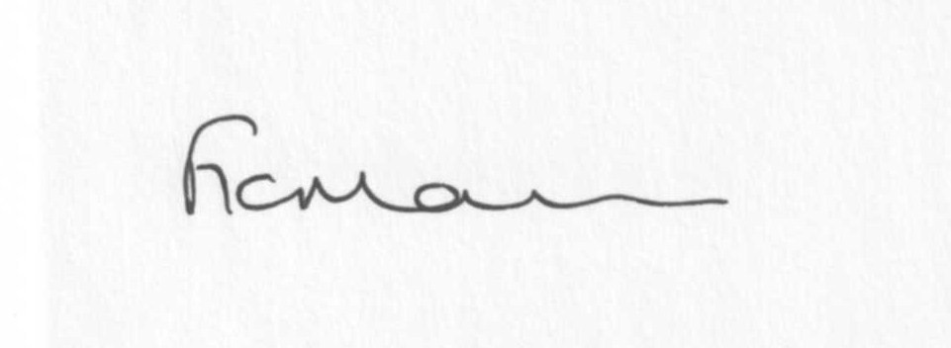

Freda Morris
Clerk to the Parish Council

