
Stottesdon and Sidbury Parish Council
Clerk: Mrs Freda Morris
18 Glebe Drive
Stottesdon
Kidderminster
Worcs
DY14 8UF

Telephone: 01746 718453
E-mail: stottesdonpc@btinternet.com

Date: 21st September 2010
To: All Parish Council members
The Public and Press

A Parish Council meeting will be held on MONDAY 27th SEPTEMBER 2010 at 7.30pm in CHORLEY VILLAGE HALL for the transaction of business as set out in the agenda below.

Yours sincerely

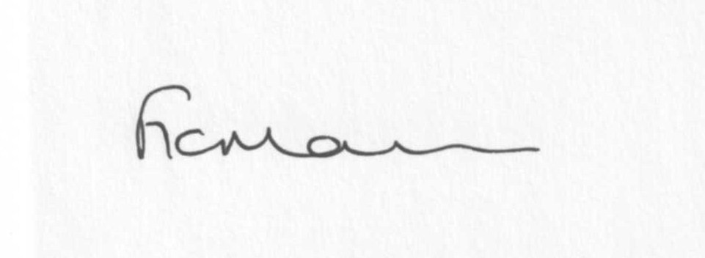 Flavia Humphreys, Broadplace Support Officer
will attend the meeting.
Mrs F Morris
Clerk to the Parish Council

AGENDA

0) Public participation
1) Apologies for absence
2) Declaration of Interests
“To receive declarations of Interest of personal and prejudicial interest on any item on the agenda in accordance with Section 50-52 of the Local Government Act & The Local Authorities (Model Code of Conduct) England Order 2001”.
3) To confirm minutes of the meeting held on August 23rd 2010 (copy attached)
4) Matters Arising from the minutes
(a) Progress report (distributed at meeting)
5) Planning applications: a) Removal of old shed and replacement new shed in different
Location – Manor House, Stottesdon
b) To confirm comments re Tree surgery/removal at The Rectory,
Stottesdon
c) Any others received after issue of agenda
6) Correspondence:
Wicksteed Leisure School Playground Inspection report.
Website Link request – Little Acorns Nursery
Local Councils update – August/September/subscription
SC – Rights of Way user survey 2010
LCR Magazine
SC – Shropshire Charter
The Clerk magazine
SC Guidance for Drainage and Flooding leaflet
ALC AGM – Saturday 6th November 10am-4pm
SC – Your Parks and Countryside Newsletter
SC – Water Efficiency Workshop – 20th October -The Lantern, Shrewsbury – 6.30pm-9pm
Various emails forwarded – list updated at meeting
Any others received after the issue of the agenda
7) Training events
8) Shropshire Economy Document comments
9) Homelessness Strategy Action Plan document comments
10) Parish matters/problems
a) Parish problems
b) Parish Watch
11) Financial matters:
a) Outstanding payments – Wicksteed Leisure Account, Clerk’s salary, ALC Account, Audit fee.
PWLB – direct debit notification
Any others received after issue of agenda.
b) Income since last meeting (distributed at meeting)
c) External Audit report
d) Funding request for insurance for Village Fireworks Display
12) ALC report
13) Shropshire Councillor’s report
14) Items for next agenda
15) Date of next meeting – 25th October 2010

Please note:
Deadline for newsletter articles 12 noon 25th September 2010

