Stottesdon and Sidbury Parish Council

The Annual Parish Meeting will be held at Willowdene, Chorley on Monday May 16th at 7.30pm.
Local Government electors for the Parish will be entitled to vote at the meeting which will be open to the public (LGA 1972, ss13(1) and 32 (1)

This is the meeting of the Parish, and all parishioners are welcome to attend and find out what is going on where you live and put new ideas forward for consideration.
The Parish Council are extremely grateful to Dr Home for inviting them to hold the meeting there.
Tea and coffee will be served.

Guest speaker will be:
Dr Matt Home who will give a short insight into the work of Willowdene.

Agenda:
00. Chairman’s welcome and introduction of guest speaker: Dr Matt Home
01. Apologies
02. Minutes of last meeting – April 26th, 2021 (copy attached)
03. Matters arising from minutes:
04. Chairman’s Annual Report
05. Shropshire Councillor’s reports
06. Organisation reports:
a) Stottesdon School/Nursery
b) Chorley Village Hall
c) South Wheatland Archive Group (SWAG)
d) WI
e) Nightingale Nurses
f) Stottesdon/Sidbury Church
g) Chorley Chapel
h) Chorley Show
i) Lengthsman Scheme
07. Parish problems
08. Queen’s Platinum Jubilee celebrations
09. Chairman’s closing comments
10. Date of next meeting – May 23rd, 2022 (Annual Parish Council meeting)

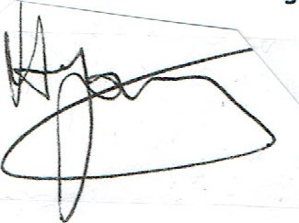
David Young - Chairman

