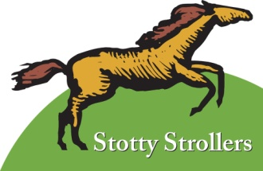

Report to the Annual Parish Meeting 2017

There is nothing new to report on this occasion. However, for the record, during 2016 we kept the Strolls Display Boards and website up to date.

Over a decade on from the launch of the Stotty Strolls walks, in 2006, we are still hoping to finally ‘hang up our boots’ this year. As we plan this, it would be good to pass on the “P3” mantle to others – P3 volunteering need not be an onerous task and we are encouraged by the continuing interest in local walks.

That interest as is evident from both the walks in the events programme being planned by the new Village Hall Committee, and from the number of visitors and walkers enjoying the countryside and patronising local pubs and shops hereabouts.

Everyone interested in developing their interest in Countryside access and the sustaining the Parish Paths network is invited to get in touch with us (718007) so that we might handover to a new team this summer.

Thank you!

Chris and Clare Tibbits 7th April 2017

